**4. REPORT**

|  |  |
| --- | --- |
| NAME | VAISHALI |
| SAP ID | 500093160 |
| COURSE | BBA(ANALYTICS AND BIG DATA) |
| SUBJECT | WEB ANALYTICS |

**Google sites:** https://sites.google.com/view/portfolio-indigo/home

My Google sites is dedicated to providing comprehensive information about Indigo Airlines, including its history,status,services,destinations, and contact information. Visitors can also find news and updates about the airline, as well as helpful details and resources for booking and managing their flights (tickets).

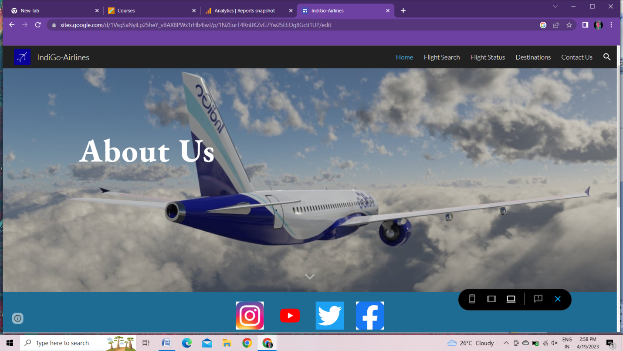

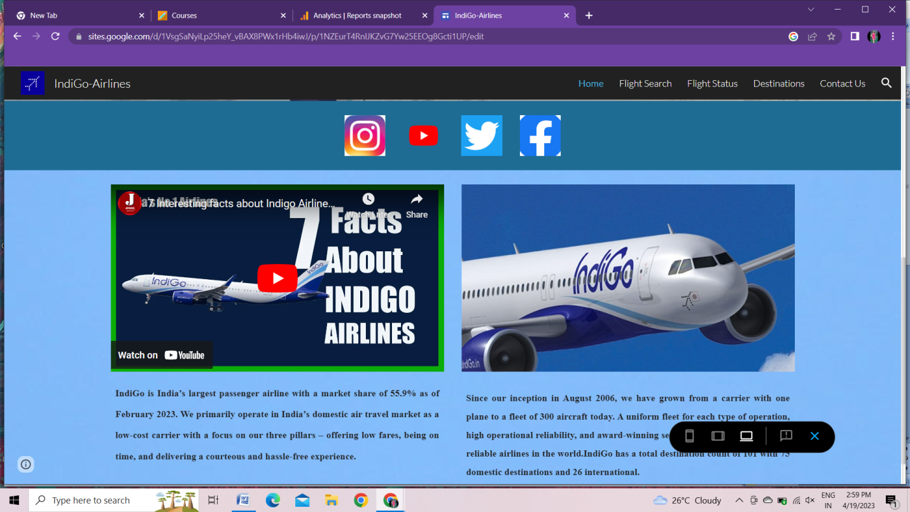

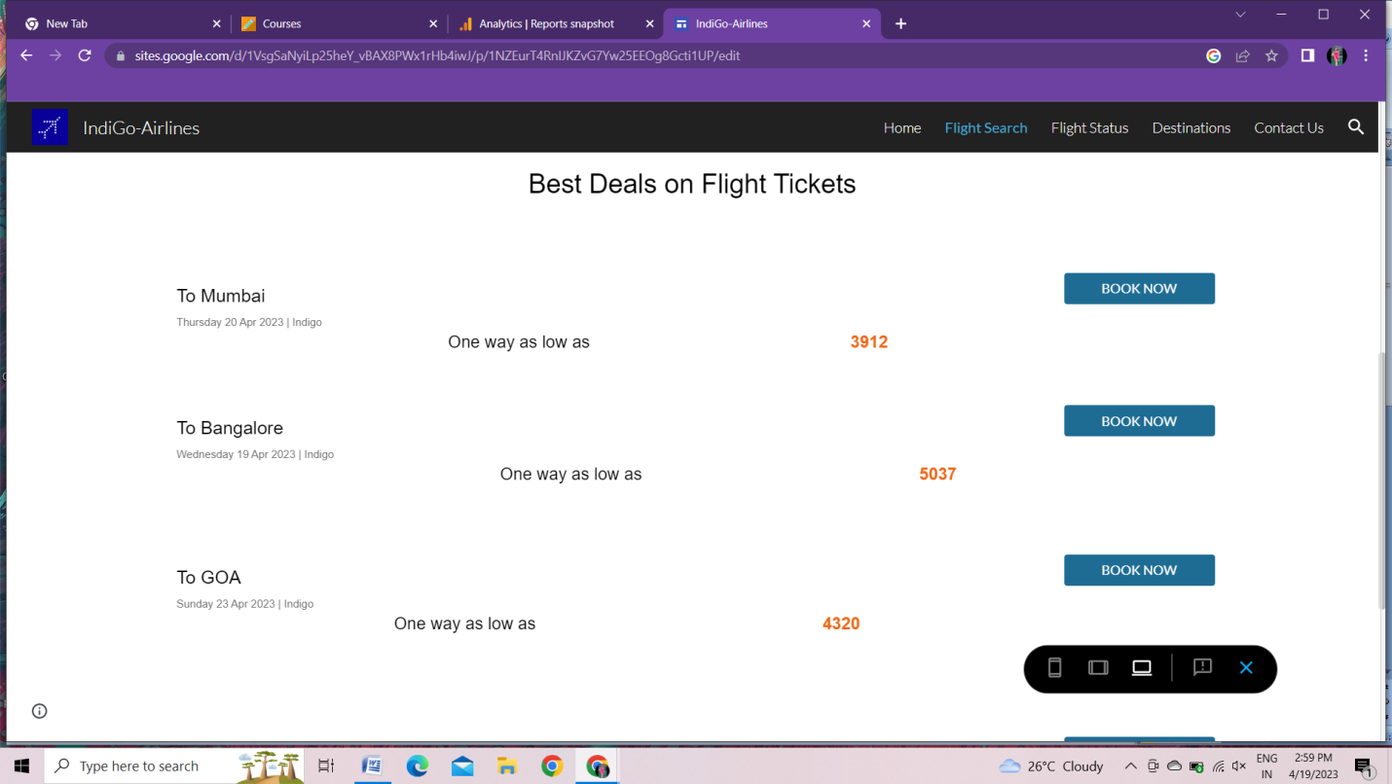

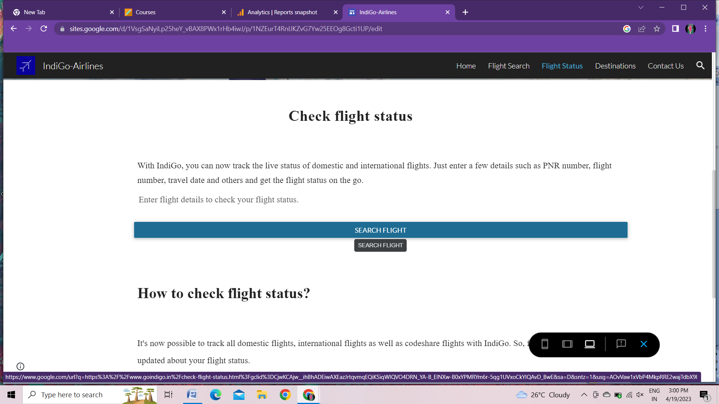

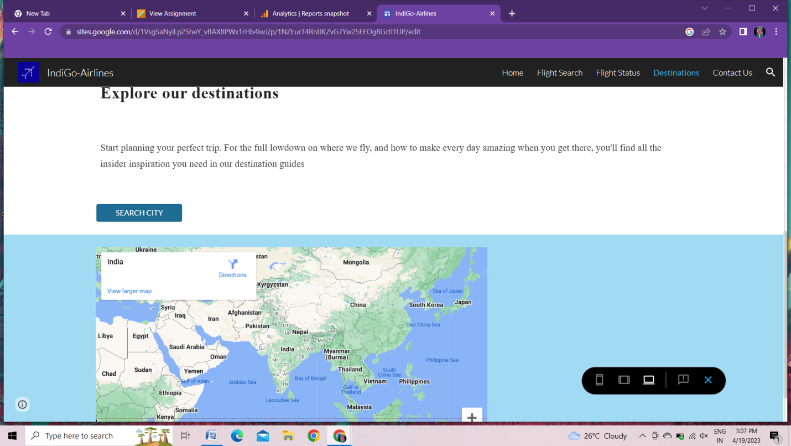

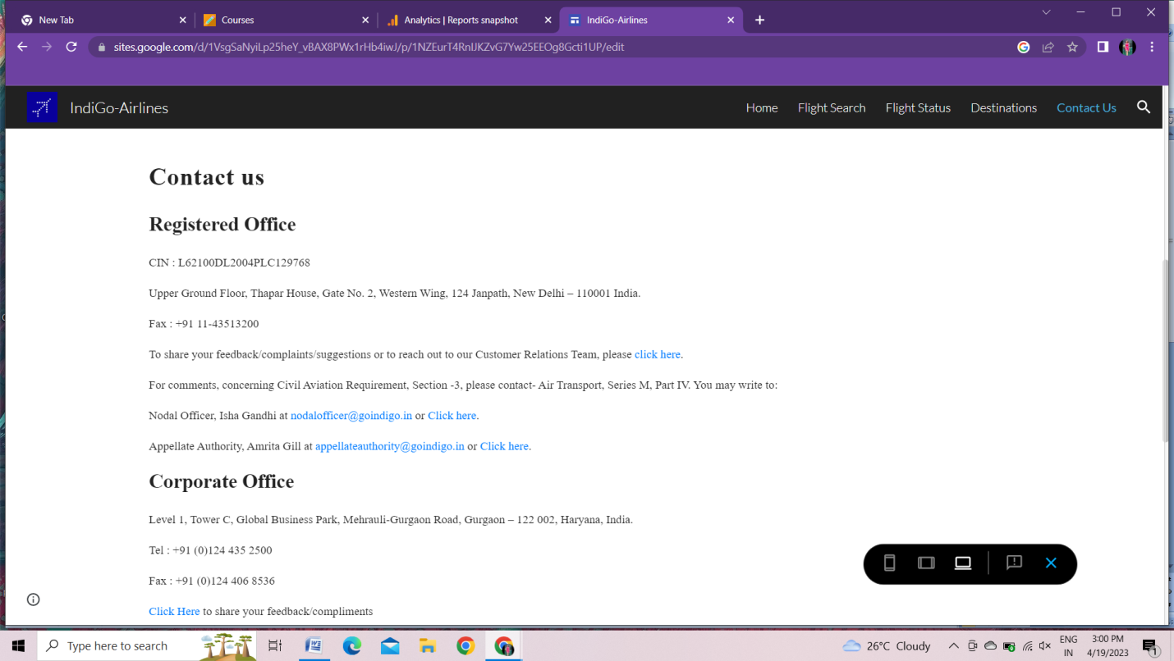

**Google Analytics:**

Google analytics is a free web analytics service offered by Google that tracks and reports website traffic and user behavior. It helps website owners understand and how people find and use their website, which pages are popular and how long users stay on the site. This can also help website owners make informed decision about improving their website performance and users experience.

1. Report snapshot

When someone clicks Reports on the left menu, an overview report known as the report snapshot is shown. It may be customized to be any overview report and discover how to edit the report snapshots.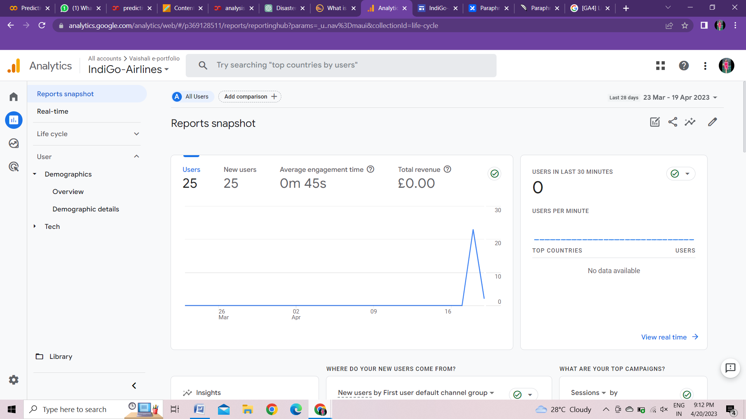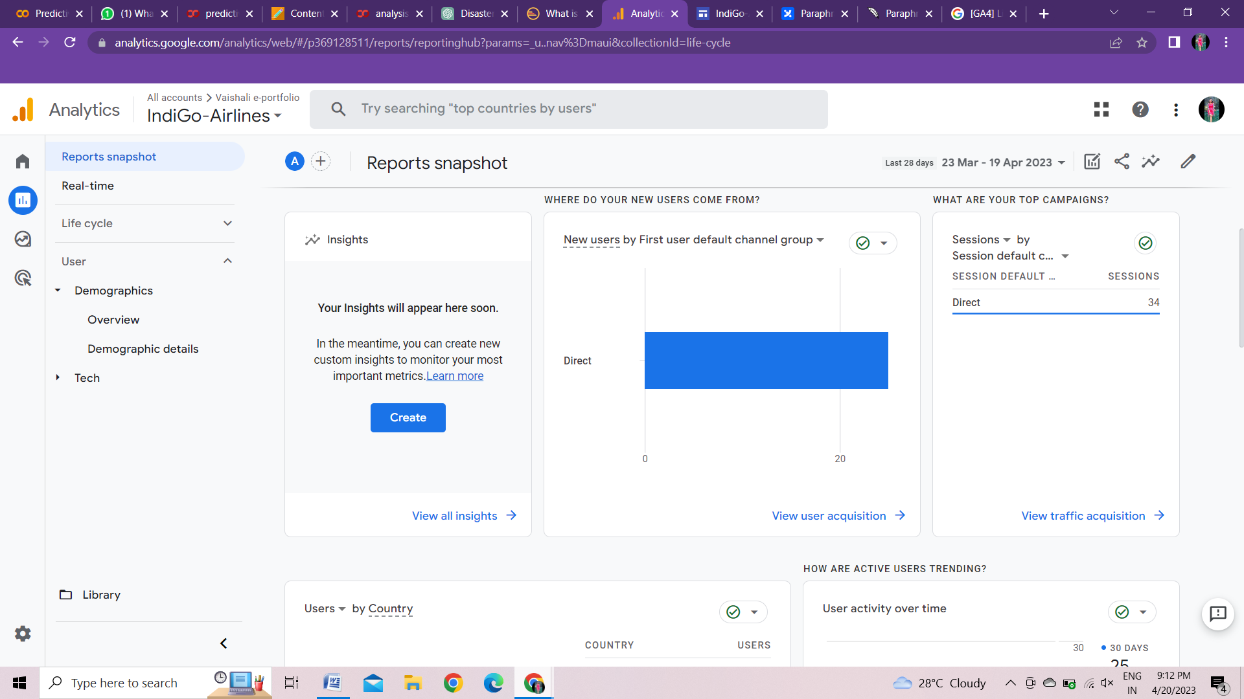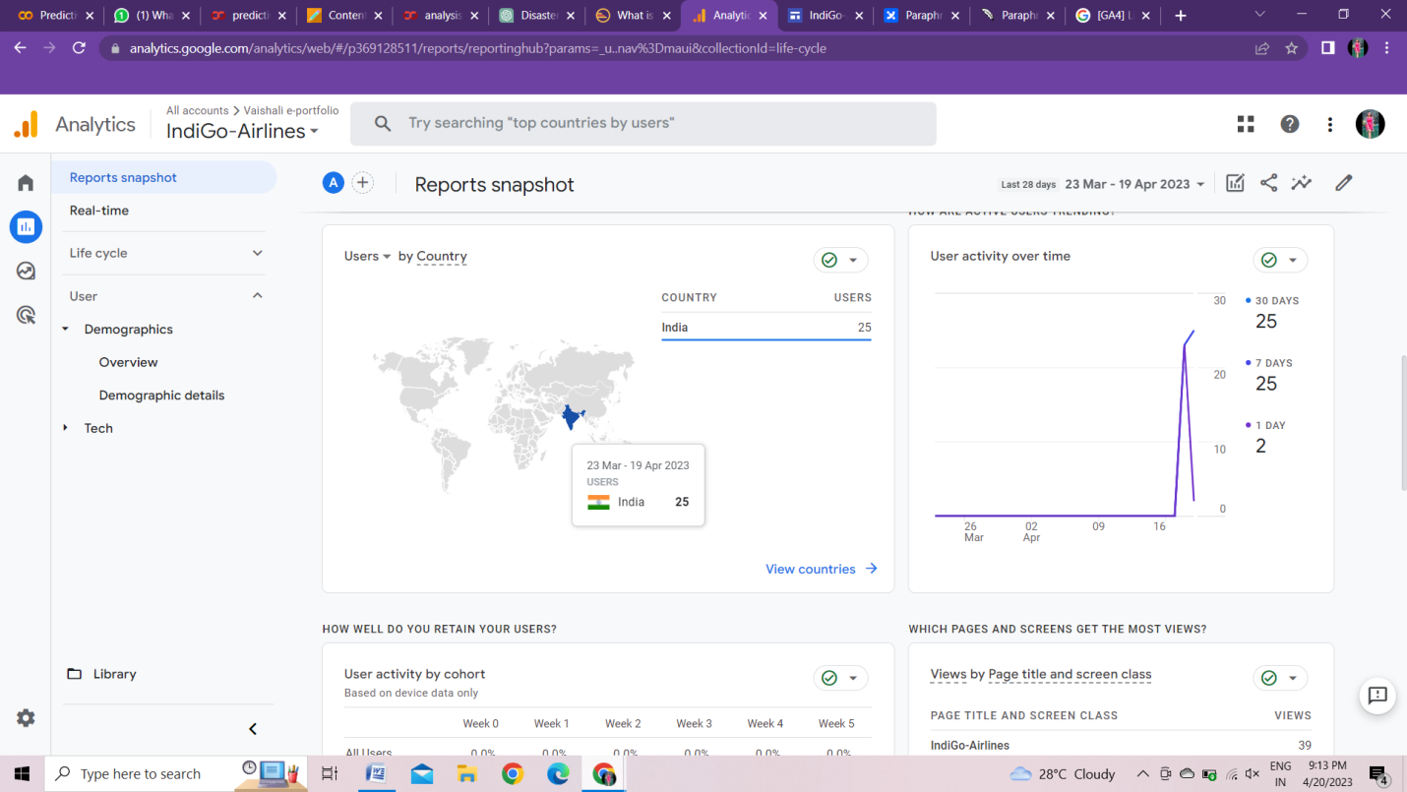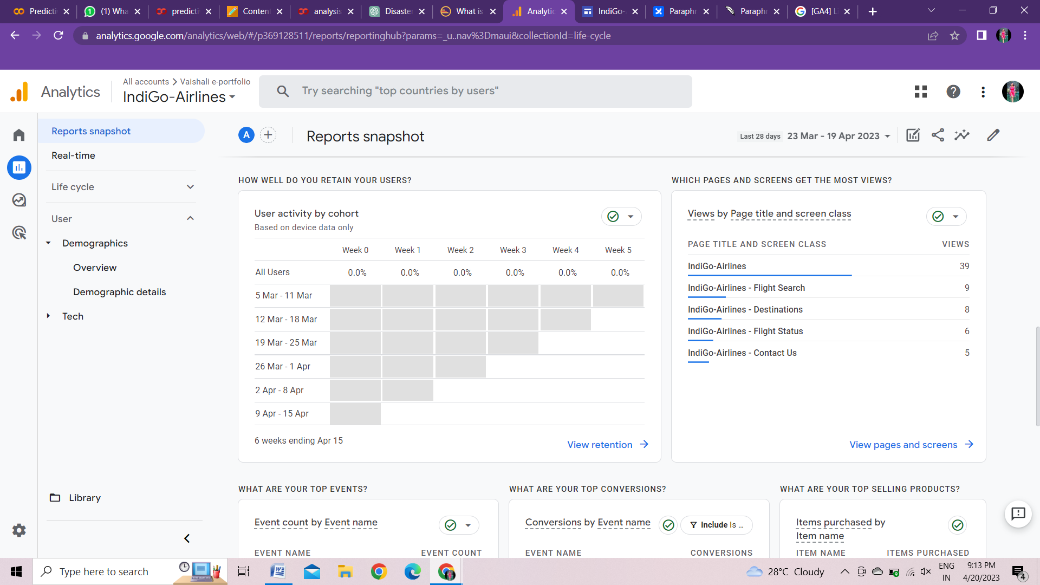

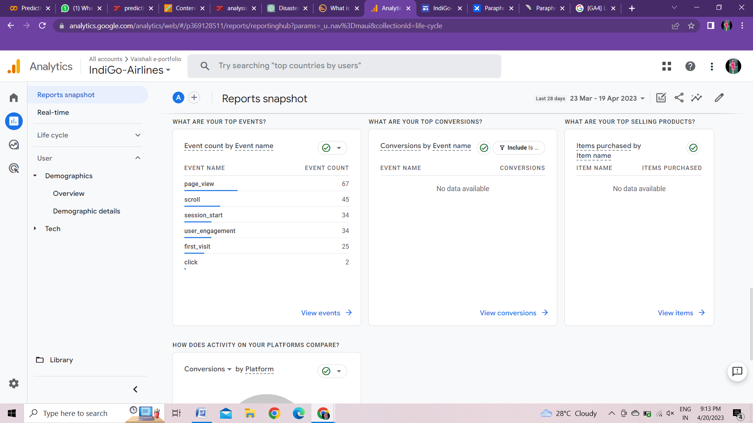

* Real time

You can keep an eye on activity on your website or app in real time. It provides activity and information for the past 30 minutes and up to the present time.

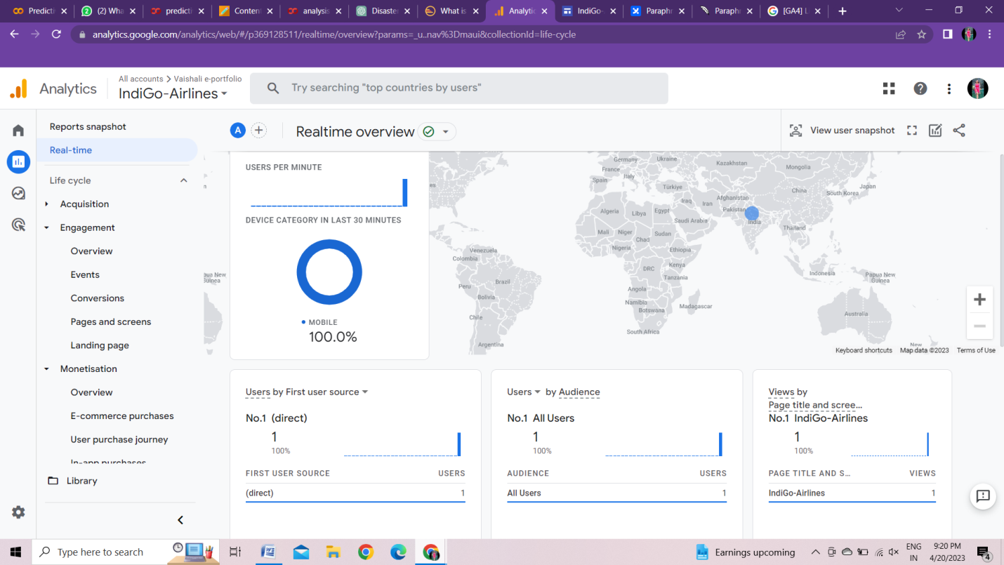

1. Life cycle

It helps you to understand each step in the customer journey from Acquisition to Retention. The life cycle collection includes the following reports:

|  |  |
| --- | --- |
| Life cycle | Reports |
| Acquisition | Overview  User Acquisition  Traffic Acquisition |
| Engagement | Overview  Events  Conversion  Pages and Screen  Landing pages |
| Monetisation | Overview  E-commerce purchases  User purchase journey  In-app purchases  Publisher ads  Promotion |
| Retention | Retention overview |

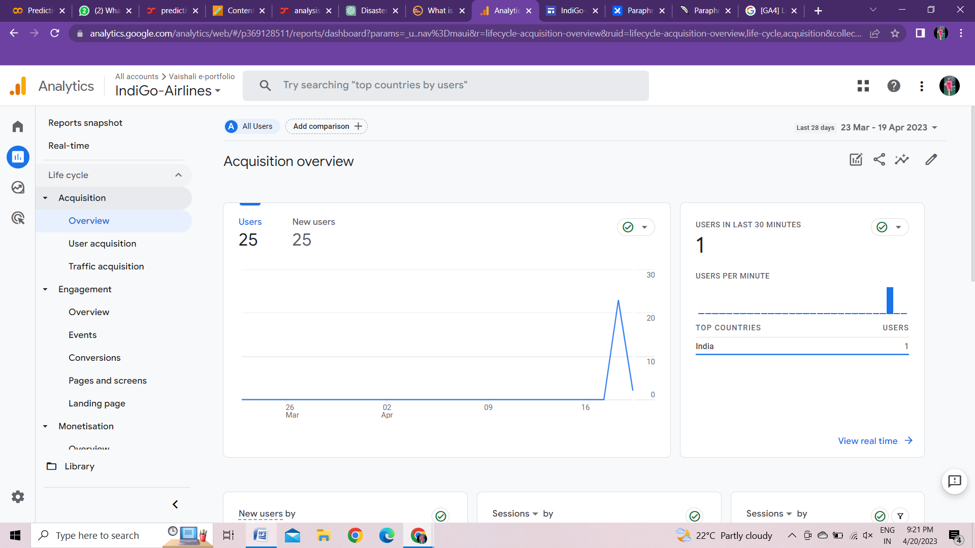

Aquisition reports help you to identify where your websites users come from. It also provides valuable insights into your audiences behavior on your website.

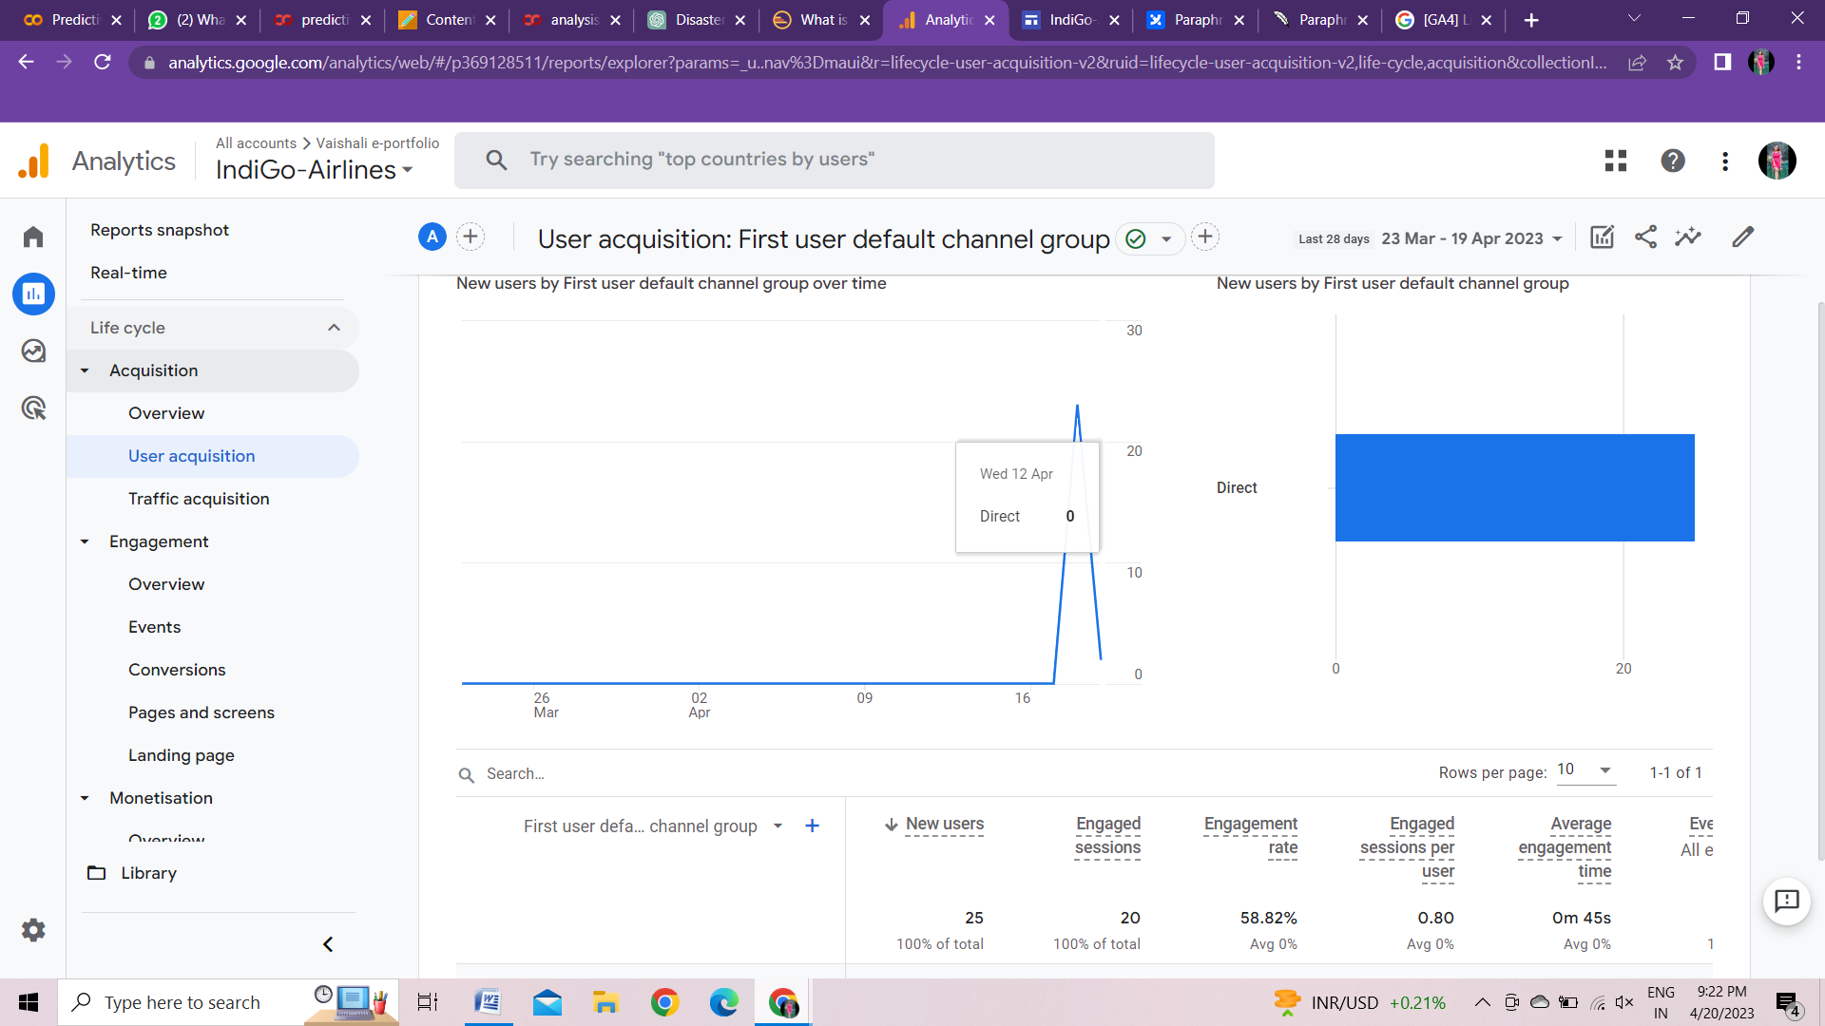

User acquisition is the process of tracking and analyzing how users find and engage with your website and which areas of your website need improvement and modification.

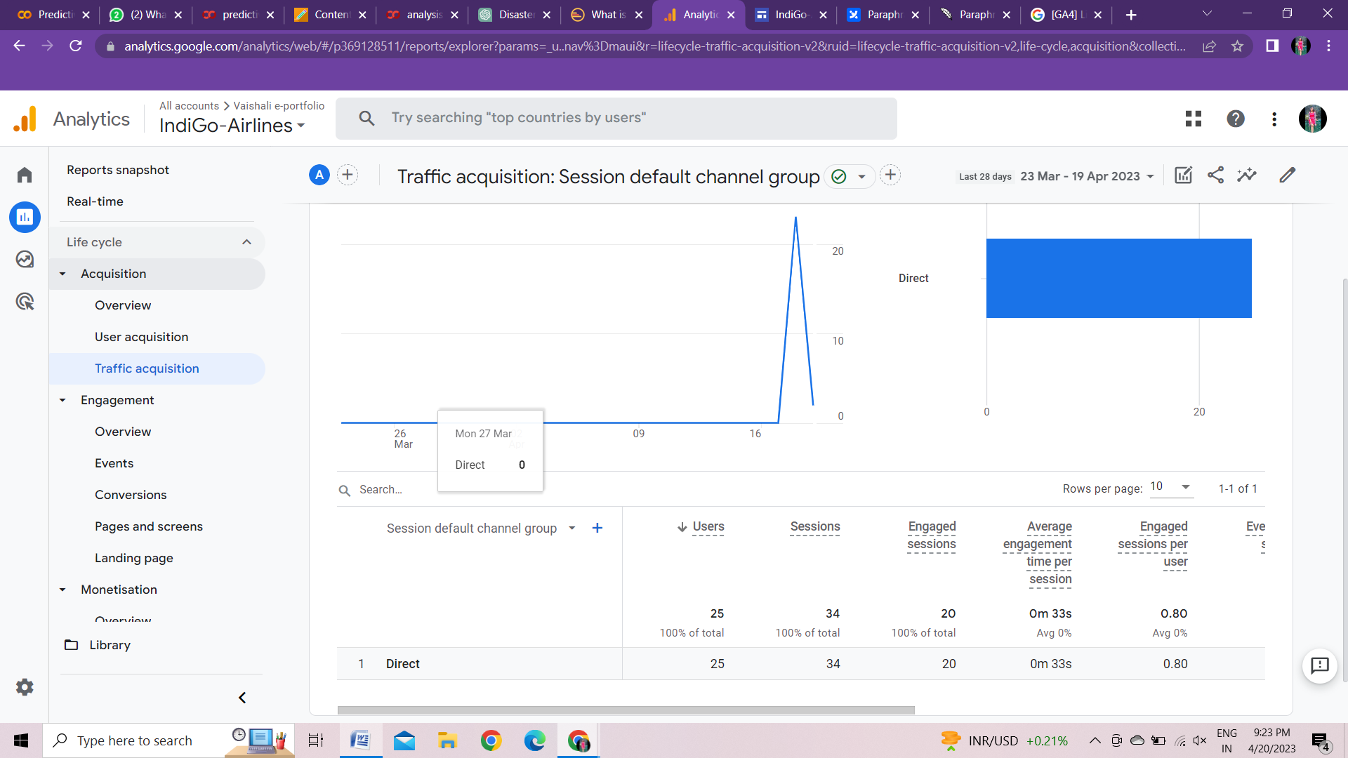

Traffic acquisition is the process of identifying and tracking the sources of traffic that drives your users to your website.

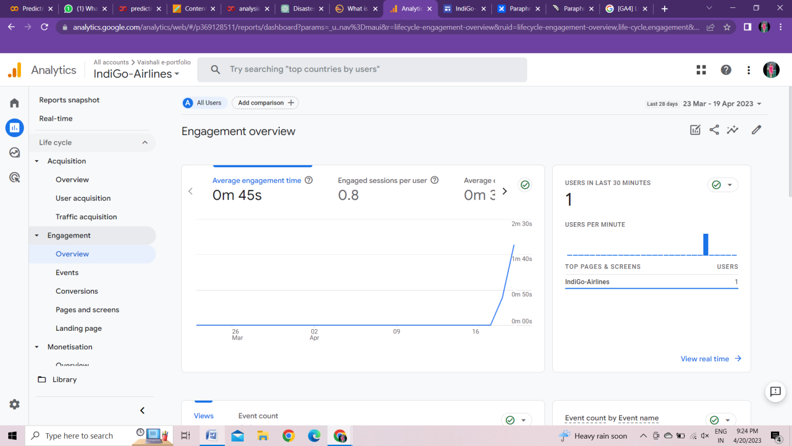

An engagement report shows that how users engage with your websites. It provides information about how long users spend time on your site, which pages they visit , and how they interact with your content.

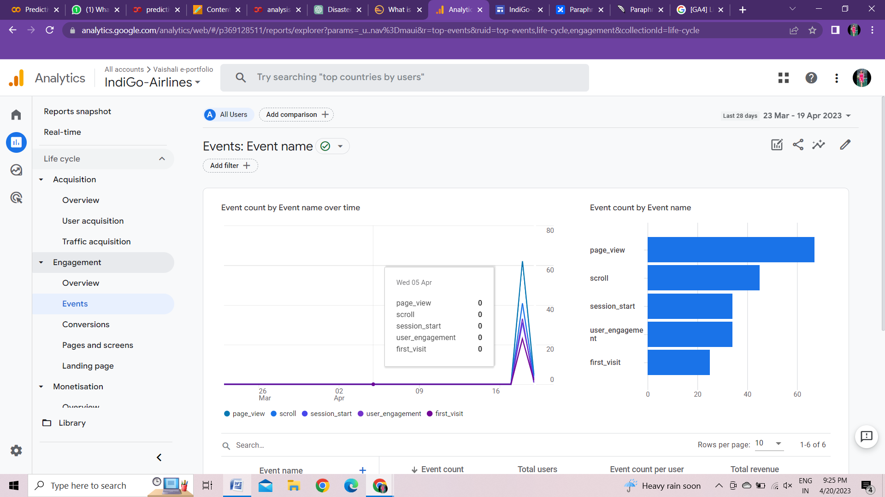

Events are specific user interactions with your website that you can track , such as click on buttons, link and or other element.

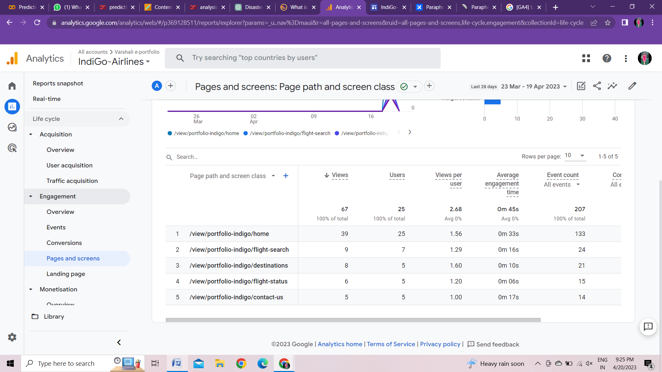

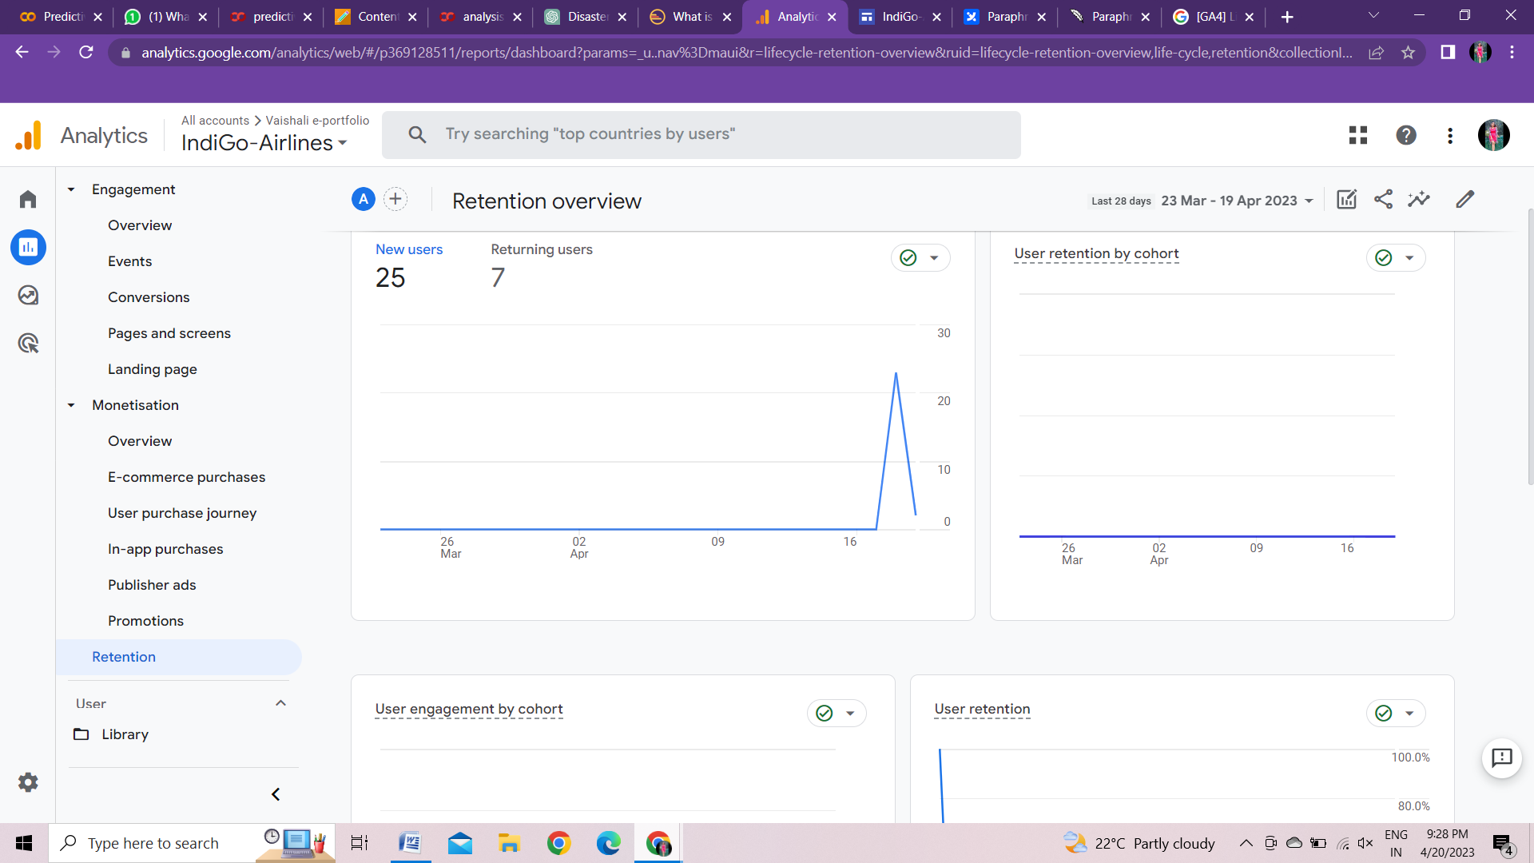

In retention that help you understand how frequently users return to your website and how long they continue to engage with your content.

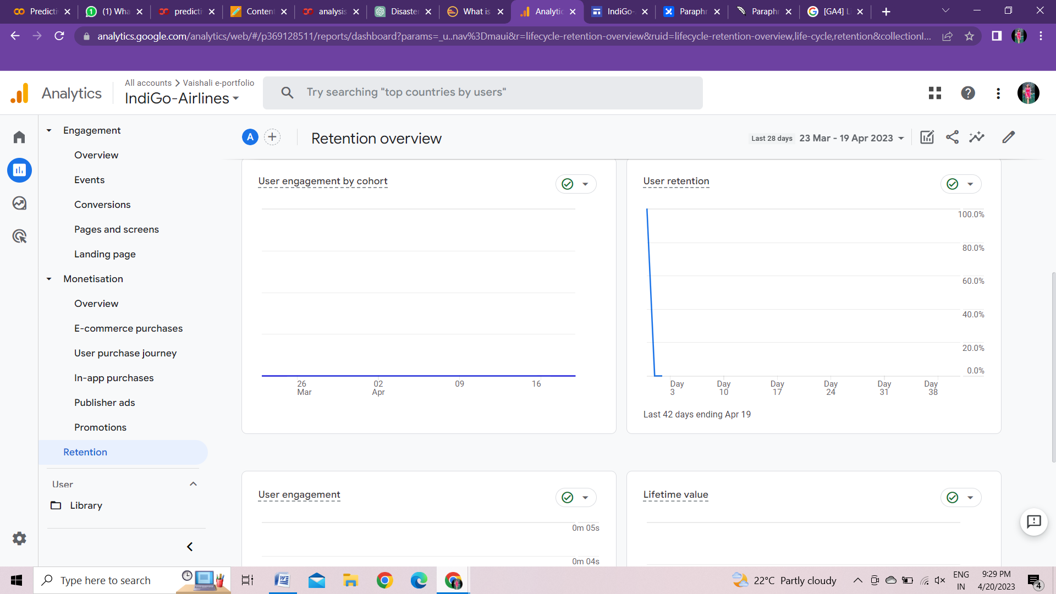

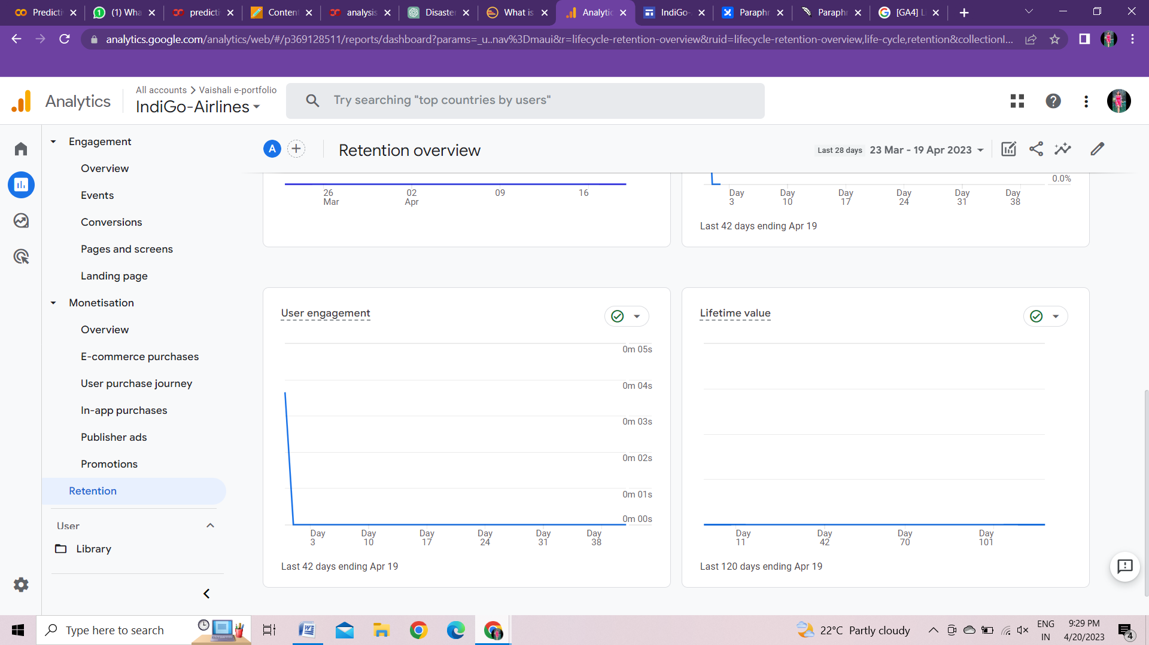

1. User

* Demographics

Overview

Demographic details

* Tech